
Project Final Report
Load Shedding Scheduler and Feeder Management System for GIKI Campus
CS112 – OOP and Design
Submitted By: Muhammad Ahmed (2025457)
Submitted To: Aneeqa Ramazan PHD Scholar FCS
Date: 23 April 2026

Project Overview: This project presents a Python-based load shedding scheduler and feeder management system developed for a simplified campus power distribution model of GIKI. The project is designed as an object-oriented solution to an electrical engineering problem in which limited available supply must be distributed fairly among different buildings. The system models major campus buildings as feeder-connected power units, assigns them priorities according to their operational importance and time slot, and then generates an ON/OFF schedule when the available supply is insufficient to meet total demand.

1. Problem Statement
In real power systems, load shedding is performed when available power is lower than the total connected demand. If such decisions are made randomly or without a structured method, the result can be unfair feeder rotations, repeated outages on the same loads, and poor prioritization of important services.
The original proposal for this project focused on feeder-based load shedding, priority handling, and optional rotation to prevent the same feeder from being switched OFF repeatedly. To make the project more realistic and easier to demonstrate, the same idea was adapted to the GIKI campus. In this model, major buildings such as the New Academic Block, Boys Hostel, Girls Hostel, Faculty of Electrical, Basic Sciences, Mechanical, Chemical, and GIKafe are treated as separate power units or feeders.
The problem addressed by the system is therefore: given a selected time slot and a limited available supply, how can the system decide which feeders should remain ON and which should be switched OFF in a way that is logical, fair, and priority-based?

2. Project Scope and System Model
The project keeps the engineering logic simple and focuses primarily on OOP design. Each major building is assigned an assumed load value in kilowatts and is categorized as Academic, Residential, or Utility. Time-based priorities are used so that academic buildings receive higher priority during class hours, whereas residential buildings receive higher priority in later hours. Utility loads remain lowest priority throughout the schedule. The scheduler compares total demand with available supply and then generates a final feeder status schedule with reasons for each decision.
Feeder ID | Building | Category | Assumed Load (kW)
F1 | New Academic Block | Academic | 180
F2 | Boys Hostel | Residential | 220
F3 | Girls Hostel | Residential | 180
F4 | Faculty of Electrical | Academic | 140
F5 | Basic Sciences | Academic | 130
F6 | Mechanical | Academic | 160
F7 | Chemical | Academic | 150
F8 | GIKafe | Utility | 70
Total Connected Load: 1230 kW

3. UML Class Diagram
The complete class structure of the project is shown below. The diagram should illustrate the parent-child relationship between PowerUnit and its derived classes, as well as the interaction of ScheduleRecord, LoadSheddingScheduler, and LoadSheddingGUI.
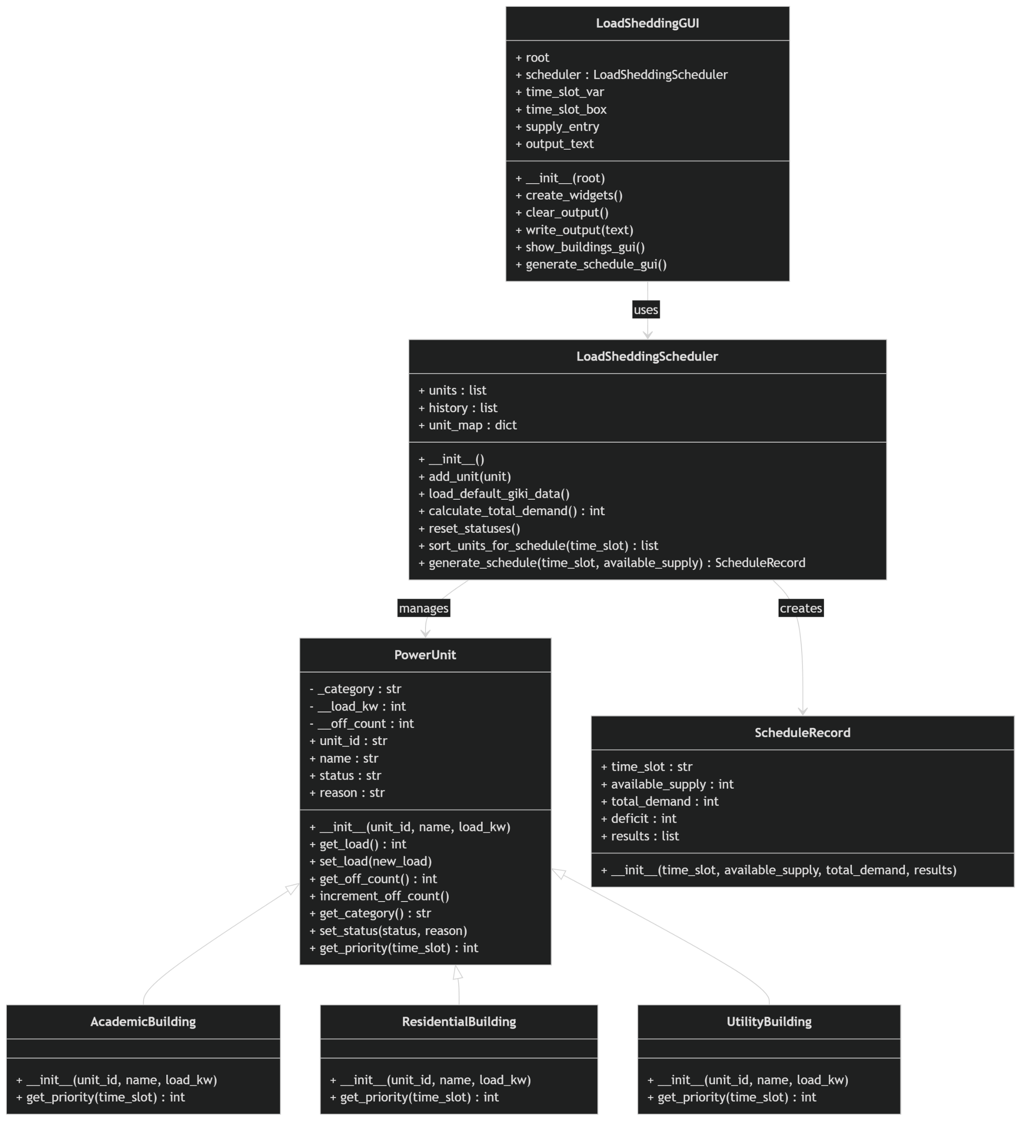

4. Use of OOP Concepts

4.1 Encapsulation
Encapsulation is demonstrated mainly in the PowerUnit class. Important feeder-related values such as load and outage count are not directly exposed throughout the program. Instead, the class stores these values using protected and private attributes such as _category, __load_kw, and __off_count. Controlled access is provided through methods such as get_load(), set_load(), get_off_count(), and get_category(). This approach improves data safety and ensures that invalid values, such as a non-positive load, cannot be assigned without validation. In this project, encapsulation is useful because feeder load and outage count are critical values that directly affect scheduling decisions.

4.2 Inheritance and Class Relationships
Inheritance is demonstrated through the relationship between PowerUnit and the three derived classes: AcademicBuilding, ResidentialBuilding, and UtilityBuilding. All three building types share common properties such as unit ID, name, status, reason, load, and category, so these are placed in the parent class. The child classes inherit these common members and then specialize the behavior according to category. This reduces repetition and makes the design more modular. In the context of the project, inheritance is important because academic, residential, and utility buildings are all power units, but they do not behave identically during scheduling.

4.3 Polymorphism and Method Overriding
Polymorphism is applied through method overriding of get_priority(time_slot). The parent class defines a default priority method, but each child class overrides it with its own logic. AcademicBuilding gives highest priority during class hours, ResidentialBuilding gives highest priority during later hours, and UtilityBuilding remains low priority throughout. The scheduler uses the same method call, unit.get_priority(time_slot), for every object, but the actual method executed depends on the type of object. This is a clear and meaningful example of runtime polymorphism in the project.

4.4 Modular and Scalable Design
The project is divided into multiple classes, each with a clear responsibility. PowerUnit and its child classes represent campus buildings, ScheduleRecord stores the result of one scheduling cycle, LoadSheddingScheduler handles the core feeder management logic, and LoadSheddingGUI handles user interaction through Tkinter. Lists and dictionaries are used to manage multiple objects efficiently, specifically units, history, and ID-based lookup. This modular structure makes the project easy to extend in the future, for example by adding more buildings, more time slots, or a database connection.

4.5 Validation and Exception Handling
The system includes input validation and exception handling at multiple points. Empty IDs, empty names, invalid loads, duplicate feeder IDs, negative available supply, and missing inputs are all checked. ValueError is raised when invalid data is found, and in the GUI these errors are shown through message boxes. This improves robustness and prevents incorrect data from affecting the final schedule.

5. Output Screenshots
Representative screenshots of the project output should be inserted in the following spaces. The recommended screenshots include the main GUI window, the campus feeder list, and one generated schedule showing total demand, available supply, deficit, and the final ON/OFF status of each building.
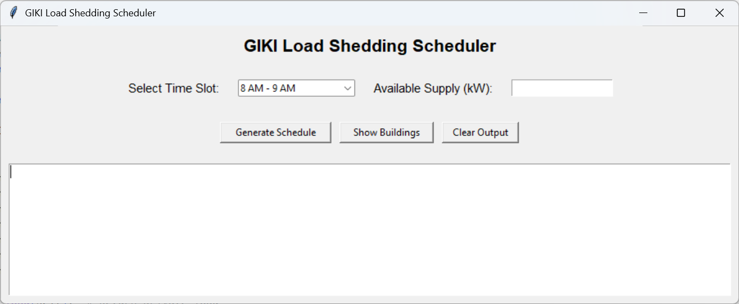
Screenshot 1: Main GUI Window

Screenshot 2: Building/Feeder Display
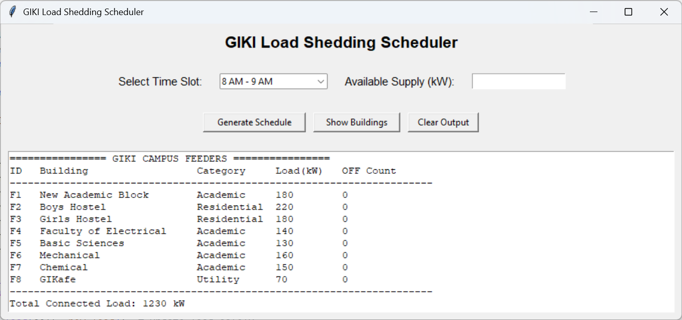

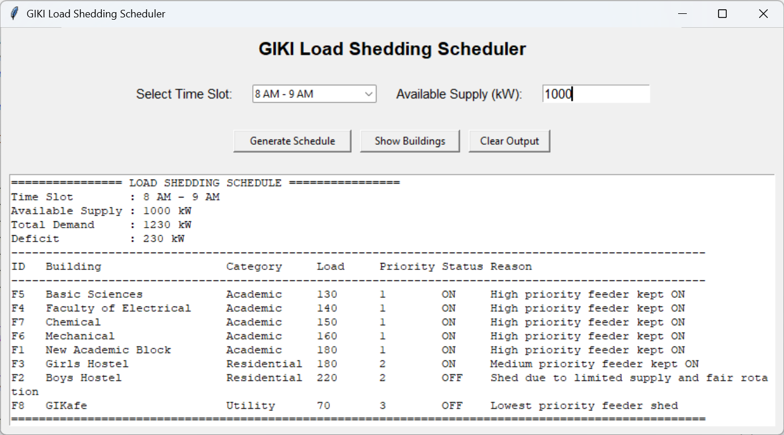
Screenshot 3: Generated Load Shedding Schedule

6. Challenges Faced During the Project
One of the main challenges was translating the original feeder-based proposal into a realistic but manageable campus-level simulation. The engineering logic had to remain simple enough for a CS112 OOP project while still representing an electrical engineering application meaningfully.
Another challenge was designing the class structure so that the project clearly demonstrated course requirements such as encapsulation, inheritance, modularity, and polymorphism. Early versions of the project worked logically, but the class relationships had to be refined to ensure that the parent-child structure and method overriding were explicit and meaningful.
A further challenge was implementing fair scheduling. It was not enough to sort feeders only by category priority; the system also needed a fairness mechanism so that the same feeder would not be switched OFF repeatedly. This was handled by including outage count in the sorting logic.
The GUI also introduced its own challenge. Since the focus of the project was on OOP and scheduling logic rather than interface design, the GUI had to remain simple while still being functional. The final solution used Tkinter to provide a clean interface for time-slot selection, supply input, and output display without changing the core scheduling logic.

7. Conclusion
In conclusion, the Load Shedding Scheduler and Feeder Management System successfully applies object-oriented programming to a simplified electrical engineering problem. The project demonstrates how a structured software design can be used to model feeder priorities, schedule load shedding based on available supply, and maintain fairness among campus loads. At the same time, it fulfills the course requirement of demonstrating OOP concepts in a clear, practical, and modular way.

